DATABASE FOR RESTAURANT TABLE   BOOKING

Group MemBERS:

N. PREETHAM REDDY  -   U101116FCS092

M. VISHWAJEET             -   U101116FCS064

M. MANASA                     -   U101116FCS069

M. RAVI TEJA                  -   U101116FCS276

Introduction :

                In this project we create a database for Restaurant Table Booking which will be useful for Restaurants as well as customers so that they can feel comfortable without any difficulty when they arrive Restaurant. This database is done on the basis of restaurant table booking app. In this database Customers can book there Table before they arrive to Restaurant through the app and can also Order the starters at the same time to have there starters Immediately when they arrive. In this database customer can reserve tables as many as they want.

 Tables created for database:

➢ Restaurant

➢ Manager

➢ Customer

➢ Owner

➢ Order

➢ Table

➢ Table Status

➢ Menu

➢ User

➢ Account Details

➢ Bill

  Entities and Attributes:

Restaurant(Restaurant_name,Location,Contact,Opening&Closing_time,Details)

Manager(Manager_id,First_name,Last_name,Contact,Address)

Customer(Customer_id,First_name,Last_name,Phone_no,Email_id)

Owner(Owner_id,First_name,Last_name,Contact,Restaurant_name)

Order(Order_id,Order_date,Price)

Table(Table_no,Details)

Table_status(Table_id,Status)

Menu (Menu_id, Item_name,Type,Category,Price)

User(User_id,First_name,Last_name,Password)

Account_datails(Account_id,Card_holder,Expiry_date,CVV)

Bill(Bill_id,Order_id,Bill_date,Amount,Discount)

 Er DIAGRAM:

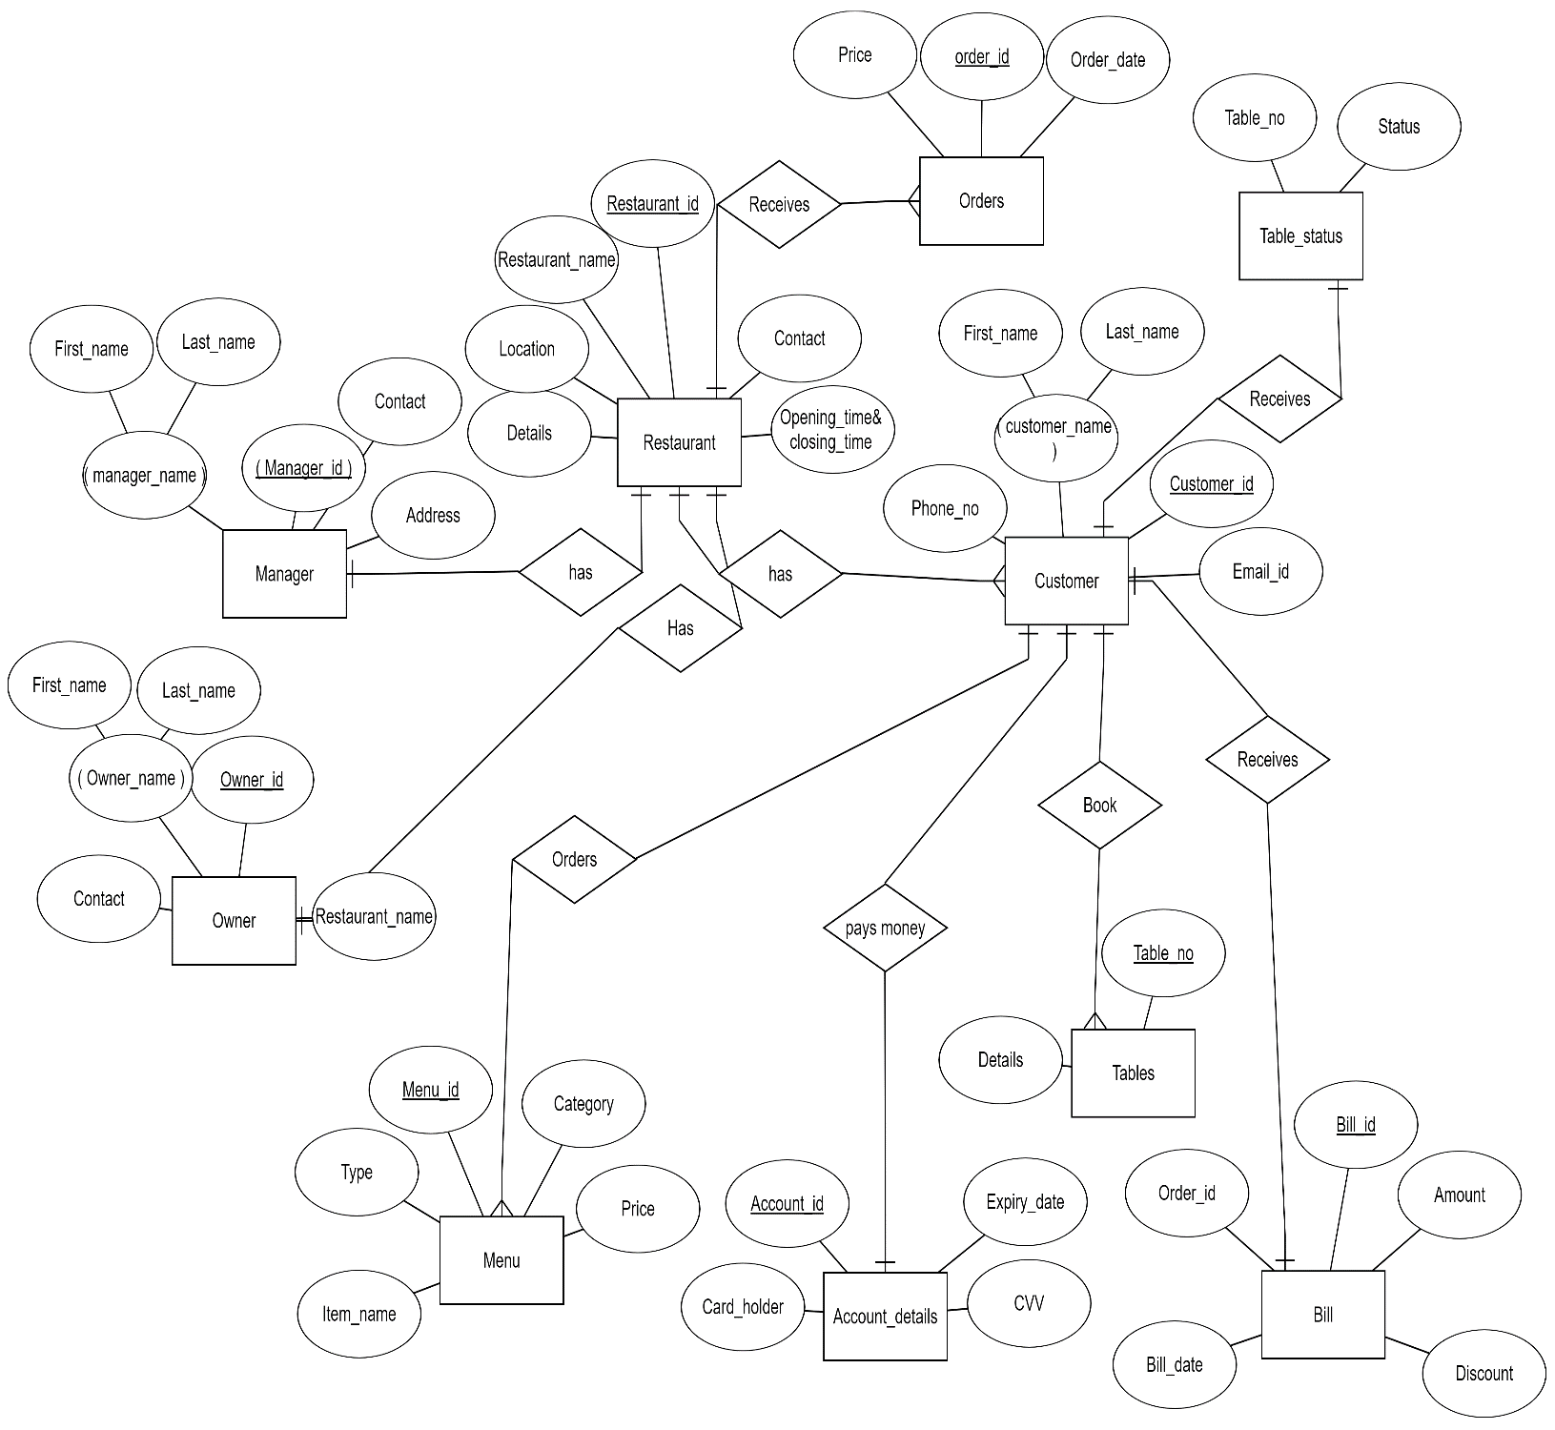

Table schema :

biLL

CREATE TABLE Bill

(

  Bill_date DATETIME NOT NULL,

  Order_id INT NOT NULL,

  Bill_id INT NOT NULL,

  Amount INT NOT NULL,

  Discount INT NOT NULL,

  PRIMARY KEY (Bill_id)

);

ACCOUNT DETAILS

CREATE TABLE Account_details

(

  Card_holder VARCHAR(50) NOT NULL,

  Expiry_date DATETIME NOT NULL,

  Account_id INT NOT NULL,

  CVV INT NOT NULL,

  PRIMARY KEY (Account_id)

);

OWNER

CREATE TABLE Owner

(

  Owner_id INT NOT NULL,

  Contact INT NOT NULL,

  Restaurant_name VARCHAR(50) NOT NULL,

  First_name VARCHAR(50) NOT NULL,

  Last_name VARCHAR(50) NOT NULL,

  PRIMARY KEY (Owner_id)

);

TABLE_STATUS

CREATE TABLE Table_status

(

  Table_id INT NOT NULL,

  Status VARCHAR(50) NOT NULL,

  PRIMARY KEY (Table_id)

);

RESTAURANT

CREATE TABLE Restaurant

(

  Details VARCHAR(50) NOT NULL,

  Location VARCHAR(50) NOT NULL,

  Restaurant_name VARCHAR(50) NOT NULL,

  Contact INT NOT NULL,

  Opening_time&_closing_time DATETIME NOT NULL,

  Owner_id INT NOT NULL,

  PRIMARY KEY (Restaurant_name),

  FOREIGN KEY (Owner_id) REFERENCES Owner(Owner_id)

);

MANAGER

CREATE TABLE Manager

(

  Contact INT NOT NULL,

  Address VARCHAR(50) NOT NULL,

  Last_name VARCHAR(50) NOT NULL,

  First_name VARCHAR(50) NOT NULL,

  Restaurant_id INT(50) NOT NULL,

  FOREIGN KEY (Restaurant_id) REFERENCES Restaurant(Restaurant_id)

);

USER

CREATE TABLE User

(

  User_id INT NOT NULL,

  Password INT NOT NULL,

  First_name VARCHAR(50) NOT NULL,

  Last_name VARCHAR(50) NOT NULL,

  Restaurant_id INT NOT NULL,

  Table_id INT NOT NULL,

  Bill_id INT NOT NULL,

  Account_id INT NOT NULL,

  PRIMARY KEY (User_id),

  FOREIGN KEY (Restaurant_id) REFERENCES Restaurant(Restaurant_id),

  FOREIGN KEY (Table_id) REFERENCES Table_status(Table_id),

  FOREIGN KEY (Bill_id) REFERENCES Bill(Bill_id),

  FOREIGN KEY (Account_id) REFERENCES Account_details(Account_id)

);

CUSTOMER

CREATE TABLE Customer

(

  Customer_id INT NOT NULL,

  Phone_no INT NOT NULL,

  Email_id VARCHAR(50) NOT NULL,

  First_name VARCHAR(50) NOT NULL,

  Last_name VARCHAR(50) NOT NULL,

  Restaurant_id INT NOT NULL,

  Bill_id INT NOT NULL,

  PRIMARY KEY (Customer_id),

  FOREIGN KEY (Restaurant_id) REFERENCES Restaurant(Restaurant_id),

  FOREIGN KEY (Bill_id) REFERENCES Bill(Bill_id)

);

ORDER

CREATE TABLE Order

(

  Order_date DATETIME NOT NULL,

  order_id INT NOT NULL,

  Price INT NOT NULL,

  Restaurant_id INT NOT NULL,

  PRIMARY KEY (order_id),

  FOREIGN KEY (Restaurant_Id) REFERENCES Restaurant(Restaurant_id)

);

TABLE

CREATE TABLE Table

(

  Details VARCHAR(50) NOT NULL,

  Table_no INT NOT NULL,

  Customer_id INT NOT NULL,

  PRIMARY KEY (Table_no),

  FOREIGN KEY (Customer_id) REFERENCES Customer(Customer_id)

);

MENU

CREATE TABLE Menu

(

  Menu_id INT NOT NULL,

  Type INT NOT NULL,

  Category VARCHAR(50) NOT NULL,

  Item_name VARCHAR(50) NOT NULL,

  Price INT NOT NULL,

  Customer_id INT NOT NULL,

  User_id INT NOT NULL,

  PRIMARY KEY (Menu_id),

  FOREIGN KEY (Customer_id) REFERENCES Customer(Customer_id),

  FOREIGN KEY (User_id) REFERENCES User(User_id)

);

 Translation of ER diagram to Relational Database:

* Convert all the Entities in the diagram to tables
* All single valued attributes of an entity are converted to a column of the table
* Key attribute in the ER diagram becomes the Primary key of the table.
* Declare the foreign key column, if applicable
* One can ignore derived attribute, since it can be calculated at any time
* Any multi-valued attributes are converted into new table.
* Any composite attributes are merged into same table as different columns.

 RELATIONAL SCHEMA:

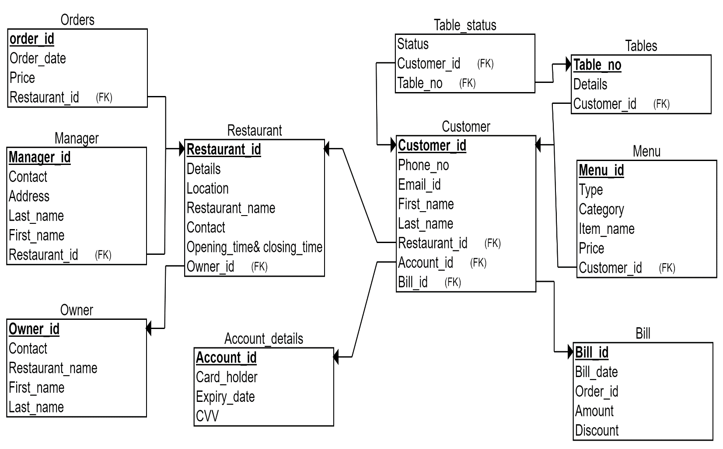

Conversion Process:

|  |  |  |
| --- | --- | --- |
| **Entity/Relationship** | **Table** | **Remarks** |
| Restaurant | Restaurant | It is an entity and has the same name in relational database |
| Owner | Owner | It is an entity and has the same name in relational database |
| Manager | Manager | It is an entity and has the same name in relational database |
| Customer | Customer | It is an entity and has the same name in relational database |
| Order | Order | It is an entity and has the same name in relational database |
| Table | Table | It is an entity and has the same name in relational database |
| Table_status | Table_status | It is an entity and has the same name in relational database |
| User | User | It is an entity and has the same name in relational database |
| Menu | Menu | It is an entity and has the same name in relational database |
| Bill | Bill | It is an entity and has the same name in relational database |
| Account_Details | Account_Details | It is an entity and has the same name in relational database |
| Receives |  | It is a 1-N relationship between Restaurant and Orders |
| Has |  | It is a 1-N relationship between Restaurant and Customers and also between Restaurant and Users |
| Orders |  | It is a 1-N relationship between Customer and Menu and also between User and Menu |
| Can Book |  | It is a 1-N relationship between Customer and Tables |
| Has |  | It is a 1-1 relationship between Restaurant and Manager and also  Between Restaurant and Owner |
| Receives |  | It is a 1-1 relationship between User and Table status and also  Customer and Bill |
| Pay Money |  | It is a 1-1 relationship between User and Account Details |

Functional DEPENDENCIES:

Restaurant

PRIMARY KEY Restaurant_Id

Restaurant_id->Restaurant_name

Restaurant_id->Owner_id

Restaurant_id->location

Restaurant_id->contact

Restaurant_id->Manager_id

Restaurant_id-> ( Restaurant_name, Location, Contact,Details, Opening_time & closing_time, Owner_id)

Order

Order_id Primary key

Order_id->Bill_id

Order_id->order_date

Order_id->Price

Oder_id-> (Order_date, Price, Bill_id)

Bill

bill_id Primary key

Order foreign key references order(order_id)

Bill_id->Amount

Bill_id->bill_date

Bill_id->Order_id

Bill_id->Discount

Bill_id-> ( Amount, bill_date, Order_id, Discount)

Owner

Owner_id primary_key

Owner_id->Restaurant_name

Owner_id->Contact

Owner_id->Owner_name

Owner_id->First_name

Owner_id->Last_name

Owner_id-> (Restaurant_name, Contact, Owner_name, First_name, Last_name)

Account details

Account_id primary key

Account_id->Card_holder

Account_id->CVV

Account_id->Expiry_date

Account_id->Customer_name

Account_id-> (Card_holder, CVV, Expiry_date, Customer_name)

Menu

Menu_id primary key

Menu_id->item_name

Menu_id->Table_id

Menu_id->Type

Menu_id->Category

Menu_id->Price

Menu_id-> (Item_name, Table_id, Type, Category, Price)

Table status

Table_no primary key

Table_no->Table_no

Table_no->Status

Table_no-> (Table_no, Status)

Manager

Manager_id primary key

Manager_id->Manager_name

Manager_id->First_name

Manager_id->Last_name

Manager_id->Contact

Manager_id->Address

Manager_id->Restaurant_name

Manager_id-> (Manager_name, First_name, Last_name, Contact, Address, Restaurant_name)

TABLES

Table_no Primary key

Table_no->Table_no

Table_no->Details

Table_no-> (Table_no, Details)

Customer

Customer_id primary key

customer_id->Menu_id

Customer_id->Customer_name

Customer_id->First_name

Customer_id->Last_name

Customer_id->contact

Customer_id->Email

Customer_id->Table_id

Customer_id-> (Menu_id, Customer_name, First_name, Last_name, contact, Email, Table_id)